JV Mathletes 10/5/16
Tehachapi

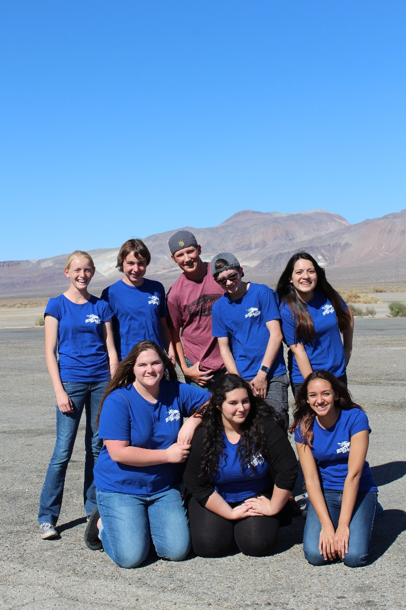
Top row: Rachel Fitt, Scott Hennarty, Carter Silva, Jake Graves, Jeniffer Velazquez
Bottom row: Sam Marcinko, Maddy Hernandez, Taryn Benson

October 5th was the JV Mathlete’s turn for the 2016/17 season kickoff in Tehachapi. The Broncos got off to a strong start finishing in second place for the overall meet behind first place team Desert. Carter Silva and Jeniffer Velazquez each won eight points, earning them third place individual ribbons out of the 68 competitors. Other high point Broncos were Maddy Hernandez and Scott Hennarty with five points each and Rachel Fitt with four points, while Taryn Benson and Jake Graves also contributed points.

Mathletes is an academic competition where students complete difficult math problems in a timed setting to earn points for their team. For example, the following problem was used in this meet: The sum of the digits of a certain two-digit number is 11. Reversing its digits increases the number by 27. What is the number? (The answer is 47).

The Mathletes are coached by BUHS math teacher Mrs. DeeDee Buchholz who said, “I am very impressed with how the team supported and helped each other to get ready for the meet. This is such a nice group of kids and I look forward to a successful year.” The next JV meet will be held on November 9 at Kern Valley.

